Created by: David Rubio G.
Blog: https://soceame.wordpress.com/
GitHub: https://github.com/DRubioG
Last modification date: 11/03/25

To access the memory addresses that Libero assigns to the SmartDesign IP blocks, you must have the SmartDesign open.
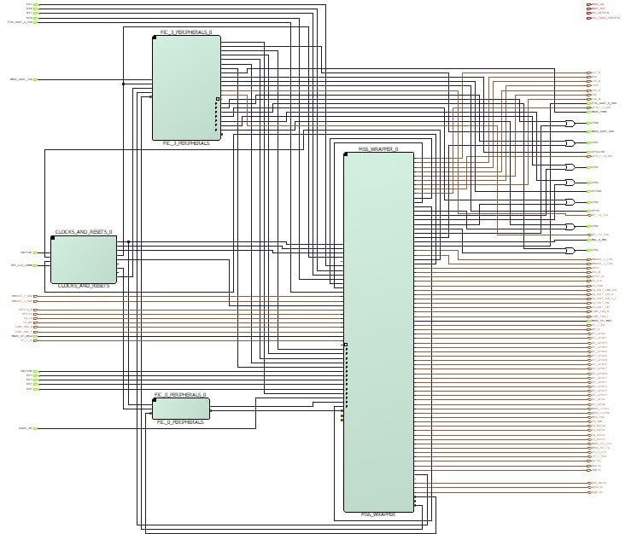
Now, all you have to do is click the following icon in the top bar.
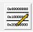
Clicking this button opens a tab showing all the memory addresses in the desired SmartDesign. The initial memory address, the allocated memory size, and the last memory address appear.
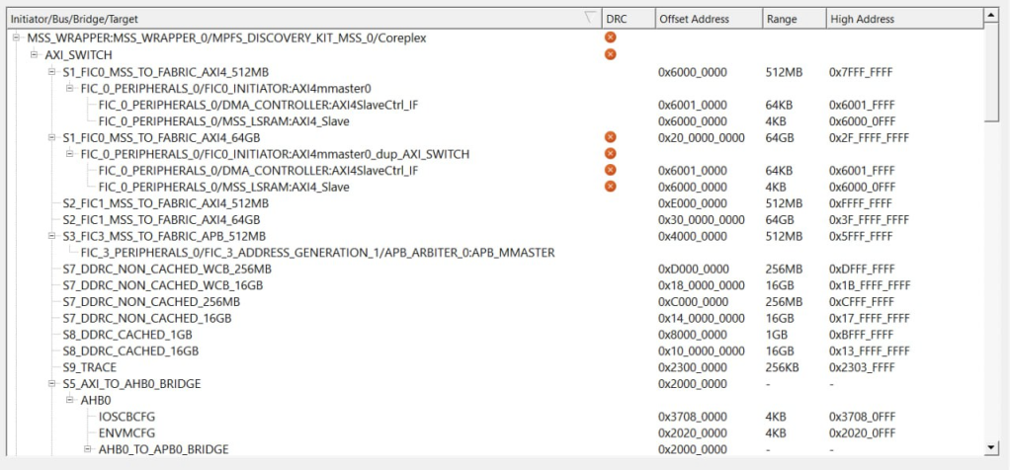
For example, it also has specific sections for peripherals connected to an interconnection block, such as an AHB_TO_APB to connect a data address bus (AHB) to a peripheral bus (APB).
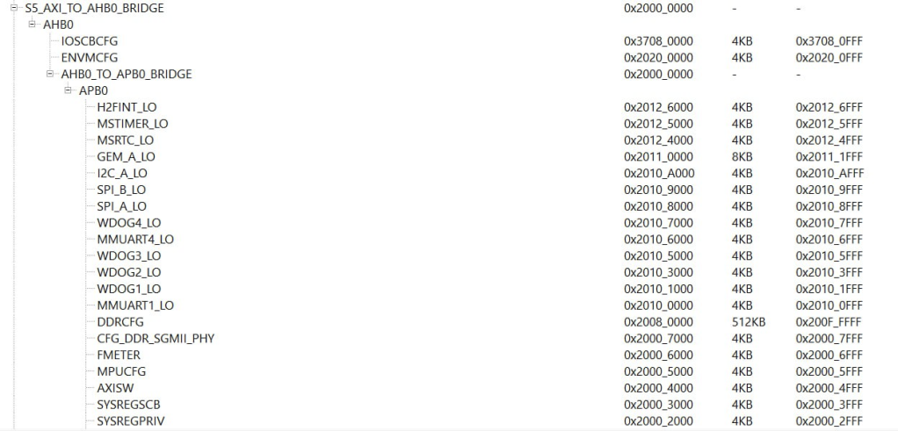
These memory addresses can also be exported.
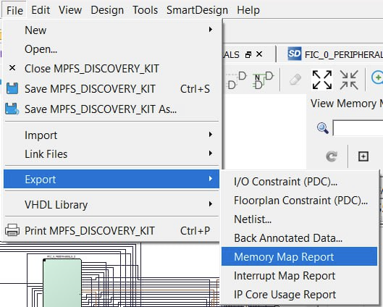
To export it, export it as JSON.
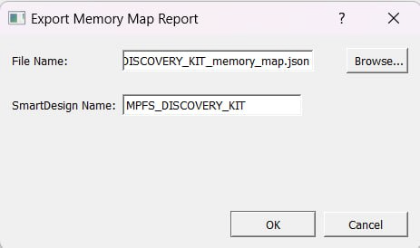
This JSON contains all the memory address information.
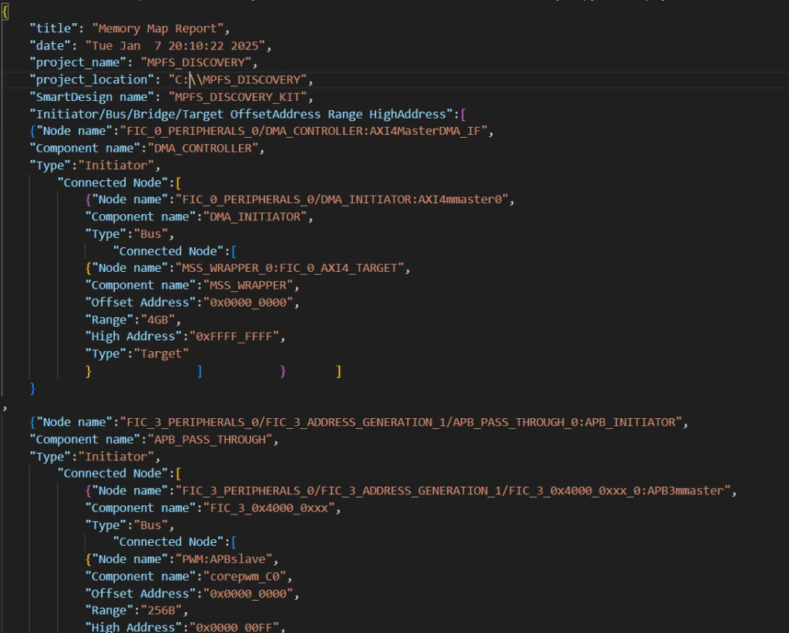
You can see the memory addresses used.
